**The Vaccination Survey Analysis Report**

**Investigating Differences between Attitudes, Intention and Behaviour of Mothers towards Vaccinating Their Children against Measles, Mumps or Rubella**

**BY**

**Name:**

**24th October 2019**

Executive summary

This report is a summary of the results, interpretations, conclusions and recommendations of an analysis done on survey data. The survey was conducted in Ukraine involving mothers as respondents, to study the attitude and behaviour of parents towards vaccination of children against Mumps, Measles /Rubella diseases (MMR). The objectives of the study were to test the effectiveness of providing behavioural science techniques in a letter addressed to parents from schools and health care professionals about the importance and safety of the MMR vaccine or the danger of contracting measles, mumps, or rubella. Data were collected in two waves of the survey in order to have a control group for the experiment. The data contained interval and categorical variables; therefore, the descriptive analysis done was frequency distribution analysis. The inferential analysis was mainly focused on solving four hypotheses. The techniques employed for this task include Chi-square test of independence, Analysis of variance (ANOVA) and Ordinal logistic regression. When the respondents are grouped according to the letter, they received some of the main findings include; Average age for all parents and their children who participated in the survey was similar per group. All the groups were similar in terms of settlements, region, financial status and education. However, the marital status had a significant relationship with the type of group a parent was in. The questions asked were statistically significant in collecting appropriate data according to the results of reliability analysis. Exposure of parents to the messages had a significant effect on their attitude, behaviour and intention to vaccinate their children.

Table of Contents

Executive summary 2

Background and Objectives of the study 4

Methodology 6

Data collection and sample 7

Handling of ‘don’t know’/‘refused’ responses 8

Reliability of scale test 8

Hypotheses tests 8

Results and Findings 9

Frequency distribution of responses 9

Reliability of scale 12

Hypothesis 2 – Impact of messages on intentions 16

Hypothesis 3 – Impact of messages on behaviour. 18

Hypothesis 4 - Messenger effect 22

Comparing treatment control groups by signature (letter) 22

Conclusion and recommendations 25

Appendices 26

Appendix A. Stata Codes 26

**List of Figures**

Figure 1 Paired t-tests to compare the vaccine attitude change between the pre-test and post-test attitudes based on letters received. 14

Figure 2 Paired t-tests to compare the vaccine attitude change between the pre-test and post-test attitudes based on letters received 15

Figure 3 Paired t-tests to compare the vaccine attitude change between the pre-test and post-test attitudes based on letters received 15

Figure 4 Ordered logistic regression to test the impact of letters on attitude of parents 16

Figure 5 Ordered logistic regression to predict full vaccination (c10) using attitude (c13) 16

Figure 6 Paired t-tests to test the difference in the likelihood of vaccinating the current child (pre-test and post-test) 17

Figure 7 Paired t-tests to test the difference in the likelihood of vaccinating another child (pre-test and post-test) 18

Figure 8 Ordered logistic regression between parent reactions (link) depending on message and the attitude (c13) 18

Figure 9 Ordered logistic regression between parent reactions (link) depending on message 19

Figure 10 Ordered logistic regression between attitude changes (att_change) depending on message 20

Figure 11 Effects of Interventions on MMR behaviour depending on vaccination status 20

Figure 12 Effects of Interventions on MMR behaviour depending on vaccination attitudes 21

Figure 13 Ordered logistic regression investigating the effect of message and age on reaction to letters 23

Figure 14 Ordered logistic regression investigating the effect of message and education level on reaction to letters 23

Background and Objectives of the study

A medical survey was carried out in Ukraine to test for differences between attitudes, intention and behaviour of mothers to vaccinate their children against measles when they are exposed to different types of messages. The outcome/target/dependent variables are attitude, change in vaccination attitude(q13-c13), intention (c11) or behaviour(link). The independent variables are message and the various questions asked. Five letters were developed from the most effective strategies from previous behaviour science experiments to promote vaccination. The message in the letters were designed ether as recommendations from a doctor, a directive from the school administration, a directive from the education department of the country, as a wakeup call because other parents have done it. A message also could elaborate the ease and advantage of vaccination.

The hypotheses of this study were:

* Hypothesis 1: There is a direct effect of messages that contain behaviour insights techniques on vaccination attitudes of mothers.
* Hypothesis 2: There is a direct effect of messages that contain behaviour insights techniques on vaccination intention of mothers.
* Hypothesis 3: There is a direct effect of messages that contain behaviour insights techniques on vaccination behaviours of mothers.
* Hypothesis 4: There is a moderating effect of messenger on the connection between the messages and behavioural outcomes.

Methodology

The survey was conducted in two waves, in the first wave, respondents completed pre-intervention vaccine attitudes, which were asked in a separate wave to avoid directly affecting their responses during the second wave. We first asked a series of questions about the child`s age and vaccination status of their child and attitude toward vaccination. Respondents then answered a series of scale questions about attitudes toward vaccines in general from a global study, which were averaged as a pre-intervention measure of vaccine attitudes. Respondents also were asked the same scale questions but focused on MMR. Respondents were also asked if they have ever delayed or refused a recommended vaccine and reasons of refuses. Finally the intention to vaccinate the child was evaluated in 2 ways: for those who did not vaccinate their child according to the Calendar of vaccination we asked about intention to vaccinate their child against MMR for those whose children got all needed MMR vaccines we asked about the intention to vaccinate other child they might have ("If you have another child, how likely is it that you will get all the necessary measles, rubella and mumps vaccinations for him/her")

In the second wave of the study, respondents were randomly assigned by the Random number generator function in Excel to receive one of five pro-vaccine messages or a control message. Researchers randomly divided people into groups and checked that the groups were equal by key indicators: the child’s age and attitude to vaccination. Subjects were unaware of the other experimental conditions. Each respondent got 1 of 6 messages and had to choose one of 3 options to react:

* Follow the link to schedule your vaccination or visit your doctor
* Follow the link if you do not plan to vaccinate your child
* Follow the link if the information is not relevant or you are undecided

After the experimental manipulation, they were asked a series of questions designed to assess attitudes and intent to give MMR to future children: questions about attitudes toward vaccines in general from a global study and the same scale questions but focused on MMR. The last question was about the intention to vaccinate the child against MMR were evaluated in 2 ways: for those who did not vaccinate their child according to the Calendar of vaccination we asked about intention to vaccinate their child against MMR for those who’s children got all needed MMR vaccines we asked about the intention to vaccinate other child they might have (“If you have another child, how likely is it that you will get all the necessary measles, rubella and mumps vaccinations for him/her”).

Data collection and sampling

Respondents were drawn from a nationally representative online panel recruited via random sampling from a population probability sample (50 000 panellists all over Ukraine). The data come from online emails to parents (18 years old and over) with one or more children aged 18 or younger. The inclusion criteria included gender (females), age 18-55, having children under 18 y.o. living in cities with a general population over 50 000 citizens.

The first wave of the study was completed by 2017 respondents out of 27971 who were sampled and invited to the study vie e-mails/ Among those, 1277 qualified for inclusion in the study (63%). We then re-contacted all eligible respondents from Wave 1. A total of 58% of those contacted (N=738) completed Wave 2. Our sample for analysis of the impact of the message consisted of the 738 participants who completed both waves of the study.

The first wave was conducted August 01-10, 2019, and the second was conducted August 13-23, 2019. The median number of days between waves was 12. It was very important for data quality and reliability to get 100+ interviews per each letter and to save subsample structure equal to the total one. Table 1 presents sample demographics, which represent the population of females with children under 18 y.o. at home in our study. The data are analysed using ordered logistic regression in Stata 15 (Stata Corporation; College Station, TX, USA).

Handling of ‘don’t know’/‘refused’ responses

The answers “I don’t know” and “refuse to answer” are omitted in the analysis. There were less than 5% of such answers.

**Descriptive statistics**

The responses for each letter was summarized in frequency tables and grouped in terms of socio-demographic information for each letter and also by 1st and 2nd wave of the survey.

Reliability of scale test

Reliability of scale test was carried out on the questionnaire to qualify its viability in collecting sufficient data that can be used to inference the general population. Cronbach’s alpha was the determinant of reliability and alpha values above 0.5 was an indication of high reliability.

Hypotheses tests

* Paired sample t-test was used to compare the vaccine attitude change between the pre-test and post-test attitudes.
* Ordered logit model was used when for ordered dependent variable: vaccine attitude, and independent categorical variable message. This was used in order to get the odds of each letter to be in the highest rank of attitude and the odds ratio of each letter against the others.
* Chi-square test for independence was used to explore the impact of the 6 types of MMR messages on parents' MMR vaccine intentions and parents' behaviour.
* One way ANOVA test was used to test the differences in the mean of age among the 6 letter groups.

Results and Findings

Frequency distribution of responses

Table 1.Respondents’ socio-demographic information as distributed across message groups

|  |  |  |  |  |  |  |  |  |  |
| --- | --- | --- | --- | --- | --- | --- | --- | --- | --- |
|  | | Wave 1 | Wave 2 | Lttter 1 | Lttter 2 | Lttter 3 | Lttter 4 | Lttter 5 | Lttter 6 |
| 1277 | 738 | 126 | 108 | 126 | 122 | 133 | 123 |
| Settlement type | 50 К+ | 54% | 54% | 54% | 46% | 62% | 53% | 56% | 54% |
| 500К+ | 22% | 22% | 25% | 25% | **13%** | 29% | 18% | 23% |
| 1 mln+ | 23% | 24% | 21% | 29% | 25% | 18% | 26% | 23% |
| Region | East | 25% | 26% | 33% | 32% | **17%** | 27% | 21% | 27% |
| West | 22% | 22% | 21% | 19% | 24% | 20% | 26% | 21% |
| North-center | 42% | 41% | 34% | 44% | 44% | 40% | 44% | 42% |
| South | 11% | 11% | 12% | **6%** | 15% | 13% | 10% | 10% |
| Age | 18-25 | 9% | 8% | 9% | 8% | 6% | 7% | 10% | 6% |
| 26-40 | 75% | 76% | 74% | 72% | **83%** | 78% | 71% | 76% |
| 41-55 | 16% | 17% | 17% | 19% | **10%** | 15% | 20% | 18% |
| Education | Primary or incomplete middle school | 1% | 1% | 1% | 1% | 2% | 0% | **4%** | 0% |
| Complete middle school | 4% | 4% | 2% | 3% | 2% | 5% | 3% | 6% |
| Vocational school / lyceum | 9% | 7% | 8% | 7% | 4% | 6% | 7% | 10% |
| Specialized secondary education | 16% | 14% | 19% | 11% | 13% | 16% | 13% | 12% |
| Higher incomplete | 9% | 9% | 7% | 10% | 10% | **3%** | 11% | 14% |
| Higher education | 61% | 65% | 63% | 68% | 69% | 70% | 63% | 59% |
| Marital status | Married / cohabiting | 8% | 8% | 10% | 6% | 6% | 11% | 6% | 9% |
| Divorced | 80% | 82% | 84% | **89%** | 86% | **75%** | 86% | **73%** |
| Single | 10% | 8% | 6% | **4%** | 8% | 12% | 7% | 12% |
| Widow | 2% | 1% | 1% | 2% | 0% | 0% | 2% | **4%** |
| Refusal | 1% | 1% | 0% | 0% | 1% | 1% | 0% | 2% |
| Occupation | Maternity leave | 28% | 31% | 31% | 31% | 37% | 26% | 33% | 26% |
| Specialist with higher education | 18% | 19% | 18% | 19% | 17% | 18% | 14% | **26%** |
| Employee | 10% | 9% | 8% | 7% | 11% | 10% | 11% | 8% |
| House holding | 10% | 9% | 8% | 6% | **15%** | 7% | 11% | 7% |
| Skilled worker / service personnel | 8% | 7% | 8% | 7% | **2%** | 7% | 8% | 10% |
| Business owner, private entrepreneur | 7% | 7% | 5% | 8% | 6% | 7% | **3%** | 10% |
| Middle manager (head of department) | 6% | 7% | **12%** | 8% | **3%** | 11% | 5% | 4% |
| Job seeker, jobless | 6% | 5% | 5% | 6% | 4% | 5% | 6% | 4% |
| Hired manager (deputy) of an enterprise or organization/ Head of a department or regional unit | 3% | 2% | 2% | 5% | 1% | 2% | 5% | 1% |
| Other workers and technical personnel, including agricultural sphere | 1% | 1% | 1% | 0% | 1% | 2% | 2% | 1% |
| Mobile worker – not office work and not physical labor | 1% | 1% | 0% | 0% | 0% | 0% | 2% | 2% |
| I don’t work because of disability | 1% | 1% | 2% | 0% | 0% | 1% | 2% | 1% |
| Serviceman; law enforcement officer, officer of other security structures | 1% | 0% | 1% | 0% | 1% | 1% | 0% | 0% |
| Financial state of family | We lack money even for food | 2% | 2% | 2% | 2% | 3% | 2% | 2% | 1% |
| Enough money for food, but buying clothes is a financial issue | 23% | 20% | 18% | 21% | 22% | 24% | 17% | 17% |
| Enough money for food and clothes, but buying goods of long use (TV-set, refrigerator) is a financial issue | 48% | 49% | 52% | 47% | 48% | 44% | 55% | 50% |
| We can afford some expensive goods (e.g. TV-set, refrigerator) | 22% | 23% | 21% | 27% | 22% | 21% | 19% | 28% |
| We can afford anything we want | 1% | 1% | 2% | 1% | 2% | 2% | 2% | 0% |
| Hard to say/Refused | 4% | 4% | 5% | 2% | 2% | 6% | 5% | 4% |

Table2. Differences in the population tested with ANOVA for continuous variables and chi-square tests for categorical variables.

|  |  |  |
| --- | --- | --- |
| **Socio-demographic information** | **Statistical test** | **P-value** |
| Settlement type | Chi square | 0.11 |
| Region | Chi square | 0.214 |
| Age (yr) of mothers | ANOVA | 0.39 |
| Child age (yr) | ANOVA | 0.41 |
| Education | Chi square | 0.17 |
| Marital status | Chi square | 0.04 |
| Financial status, n=708 | Chi square | 0.90 |

**Reliability of scale**

The value of alpha for all pre-test and post-test scales reliability analyses are greater than 0.7 .The threshold for reliability is 0.5.

Table 3 Scales reliability

|  |  |  |
| --- | --- | --- |
| **Item** | **Response** | **alpha** |
| **Pre-test** | | |
| c11. How likely are you to have your child do all the necessary measles, rubella and mumps vaccinations? | 563 | 0.97 |
| c12. If you have another child, how likely is it that you will get all the necessary measles, rubella and mumps vaccinations for him/her? | 686 | 0.97 |
| c13. What is your attitude to the vaccination? | 1,245 | 0.96 |
| c81. How do you agree with the following statement? Vaccines are important for children to have. | 1,263 | 0.96 |
| c82. How do you agree with the following statement? Vaccines are safe. | 1,237 | 0.97 |
| c83. How do you agree with the following statement? Vaccines are effective. | 1,242 | 0.96 |
| c91. How do you agree with the following statement? Vaccines against measles, rubella and mumps are important for children to have. | 1,264 | 0.96 |
| c92. How do you agree with the following statement? Vaccines against measles, rubella and mumps are safe. | 1,250 | 0.97 |
| c93. How do you agree with the following statement? Vaccines against measles, rubella and mumps are effective. | 1,230 | 0.96 |
| **Post-test** | | |
| q11. How likely are you to have your child do all the necessary measles, rubella and mumps vaccinations? | 337 | 0.97 |
| q12. If you have another child, how likely is it that you will get all the necessary measles, rubella and mumps vaccinations for him/her? | 395 | 0.97 |
| q13. What is your attitude to the vaccination? | 729 | 0.96 |
| q81. How do you agree with the following statement? Vaccines are important for children to have. | 733 | 0.96 |
| q82. How do you agree with the following statement? Vaccines are safe. | 728 | 0.97 |
| q83. How do you agree with the following statement? Vaccines are important for children to have. | 728 | 0.97 |
| q91. How do you agree with the following statement? Vaccines against measles, rubella and mumps are important for children to have. | 735 | 0.96 |
| q92. How do you agree with the following statement? Vaccines against measles, rubella and mumps are safe. | 730 | 0.96 |
| c93. How do you agree with the following statement? Vaccines against measles, rubella and mumps are effective. | 727 | 0.96 |

Hypothesis 1 - Impact of messages on attitudes.

Figure 1 Paired t-tests to compare the vaccine attitude change between the pre-test and post-test attitudes based on letters received.

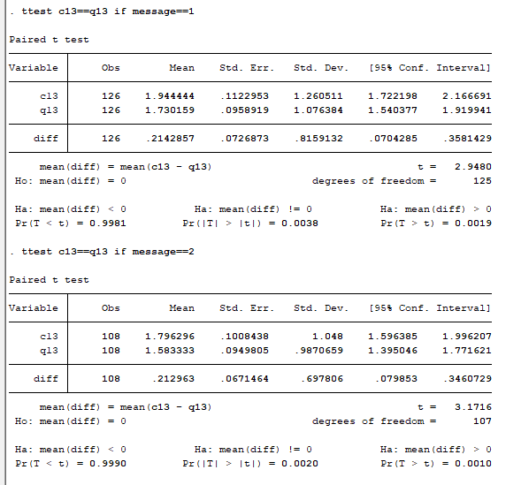

T-test resulted into the following statistical metrics if letter=1(t =2.94, P-value = 0.0019), if letter=2(t=3.1716, p-value=0.0010), if the letter=3(t=0.8692, p-value=0.1932)if letter=4 (t=1.62,p-value=0.0536), if letter=5 (t=2.78, p-value=0.0031) and if the letter=6   
(t=0.1129 ,p-value=0.4524). c13=What is your attitude to the vaccination.

Figure 2 Paired t-tests to compare the vaccine attitude change between the pre-test and post-test attitudes based on letters received

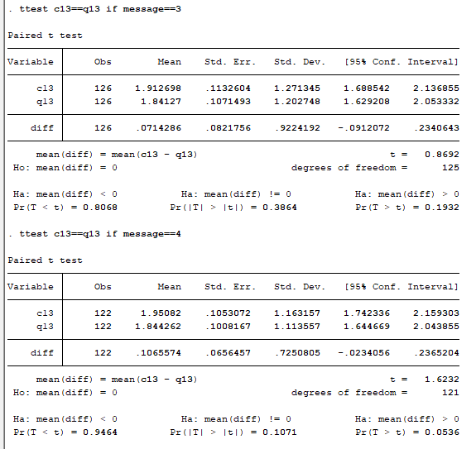

Figure 3 Paired t-tests to compare the vaccine attitude change between the pre-test and post-test attitudes based on letters received

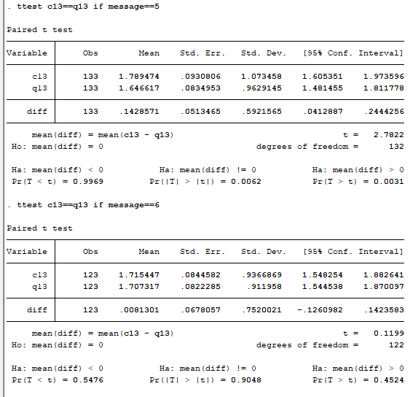

Figure 4 Ordered logistic regression to test the impact of letters on attitude of parents

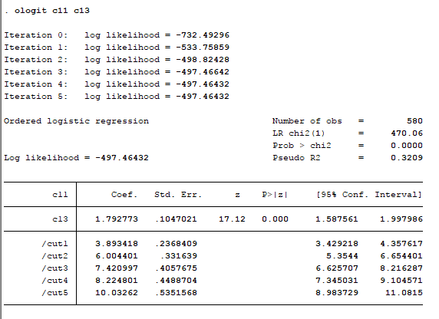

Pre-test vaccination attitude scores of mothers (n = 580), predicted whether mothers are going to vaccinate their children (coef. 1.792, conf. interval .58 - 1.99, P < 0.000).

Figure 5 Ordered logistic regression to predict full vaccination (c10) using attitude (c13)

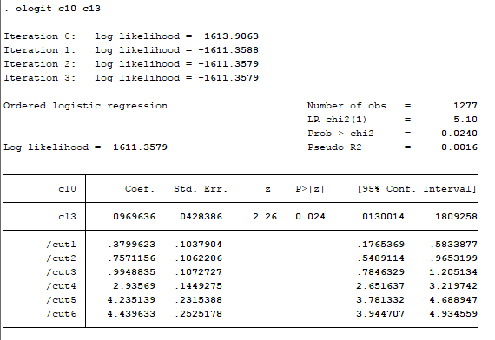

The model results are; coefficient= 0.097, confidence interval (0.013 - 0.18), P-value =0.02.

**Hypothesis 2 – Impact of messages on intentions**

A paired t-test was used to explore the impact of the 6 types of MMR messages on parents’ MMR vaccine intentions. If the child was fully vaccinated for measles, rubella and mumps mothers were asked about the likelihood of their intention (c12). If you have another child, how likely is it that you will get all the necessary measles, rubella and mumps vaccinations for him/her?” If the child didn’t have all necessary vaccination mothers were asked about their intention “c11. How likely are you to have your child do all the necessary measles, rubella and mumps vaccinations?”

Figure 6 Paired t-tests to test the difference in the likelihood of vaccinating the current child (pre-test and post-test)

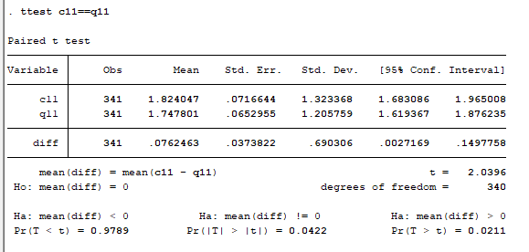

The p-value=0.0211, therefore with a 97.98% confidence the test finds a difference in mean of the two samples. Therefore it indicates a significant change from one sample to the other.

Figure 7 Paired t-tests to test the difference in the likelihood of vaccinating another child (pre-test and post-test)

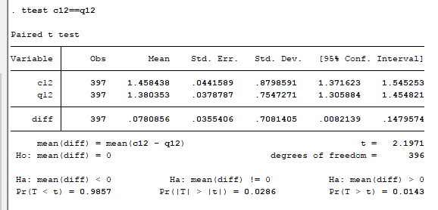

The p-value=0.0143, therefore with a 98.57% confidence the test finds a difference in mean of the two samples. Therefore it indicates a significant change from one sample to the other.

Hypothesis 3 – Impact of messages on behaviour.

Figure 8 Multinomial logistic regression between parent reactions (link) depending on message and the attitude (c13)

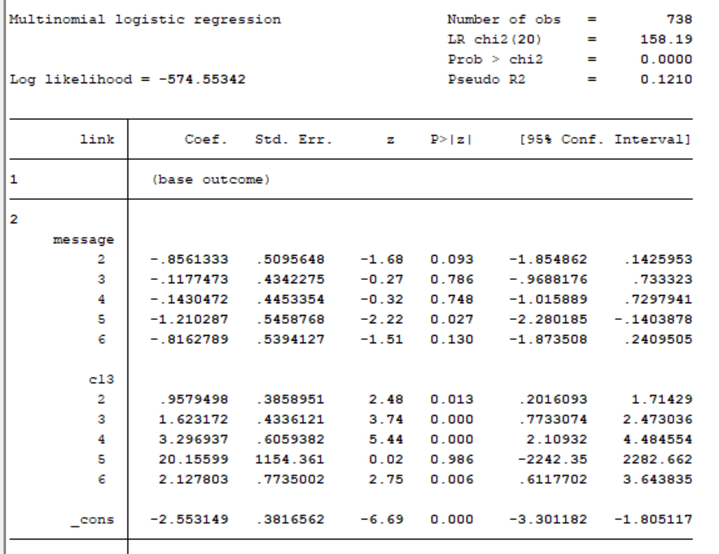

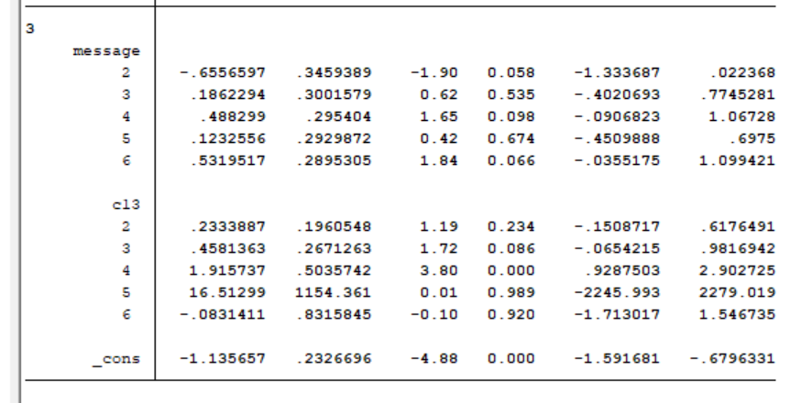

INTERPRETATION

Figure 9 Multinomial logistic regression between parent reactions (link) depending on message

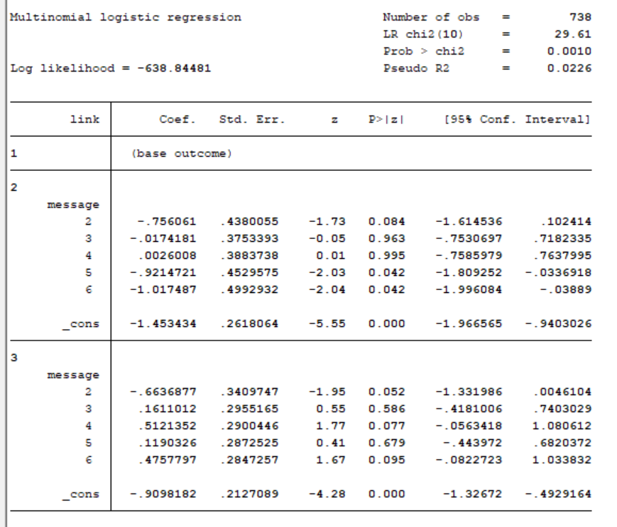

INTERPRETATION

Figure 10 Ordered logistic regression between attitude changes (att_change) depending on message

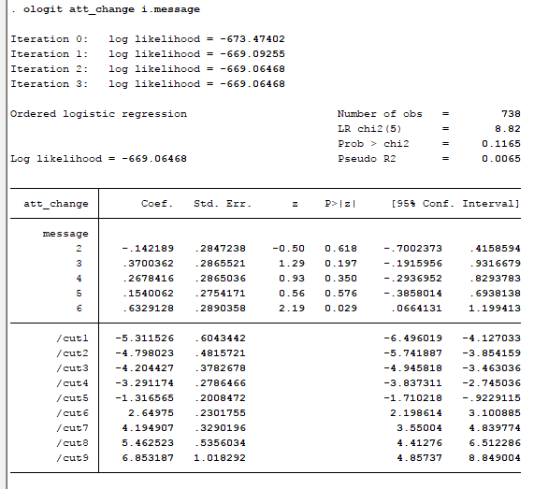

Another variable was generated to get the change in attitude which is before and after the message, att_change= (q13-c13). This variable was used in a model to determine the effect of messages on the attitude change. The p-value of the model is 0.1165; therefore the model is not significant in explaining the relationship between reaction behaviour (link) and message. Letter 6 has a significant effect on the attitude change among parents with a p-value of 0.029.

Figure 11 Effects of Interventions on MMR behaviour depending on vaccination status

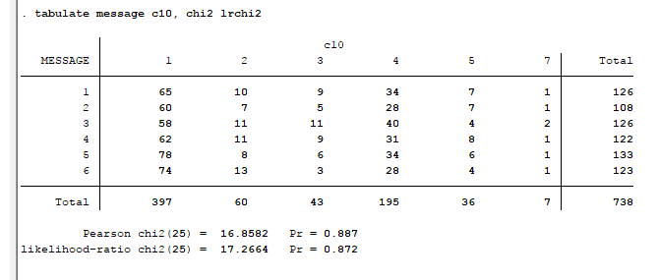

The chi square test was used to test the association between messages and vaccination status. The Pearson chi-square p-value =0.887. Statistically this is greater than 0.05 which is considered significant. Therefore the test could not find any association between messages and vaccination status.

Figure 12 Effects of Interventions on MMR behaviour depending on vaccination attitudes

Pre-test

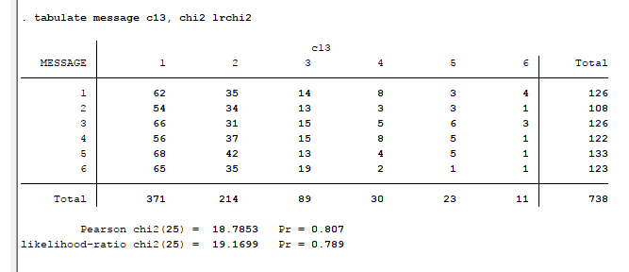

The chi square test was used to test the association between messages and vaccination attitude. The Pearson chi-square p-value =0.807. Statistically this is greater than 0.05 which is considered significant. Therefore the test could not find any association between messages and attitude.

**Figure 11 Effects of Interventions on MMR behaviour depending on vaccination intentions**

Post test

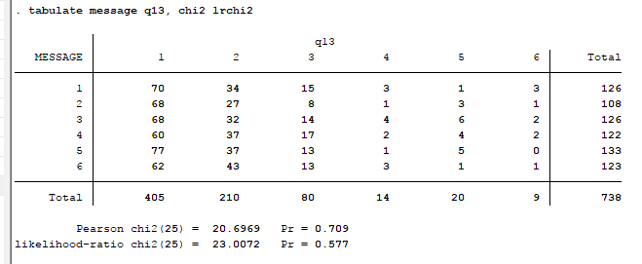

The chi square test was used to test the association between messages and vaccination attitude. The Pearson chi-square p-value =0.709. Statistically this is greater than 0.05 which is considered significant. Therefore the test could not find any relationship between messages and attitude.

Hypothesis 4 - Messenger effect

At the same time the further analysis showed the signature itself don’t drive the behaviour. The signature and content are more effective together. If the letter is signed by doctor there is a significant effect. If it is signed by school it is also significantly different. General attitude to vaccination and safeness of vaccination contributed to attitude change. There is a significant difference if letters are not signed by doctor in importance of vaccination and effectiveness of MMR vaccines. It is not solely because of signature or content but both

Comparing treatment control groups by signature (letter)

**Control for independent variables**

* Education d1
* Financial status d4
* Age c51

**Figure 13 Multinomial logistic regression investigating the effect of message and age on reaction to letters**

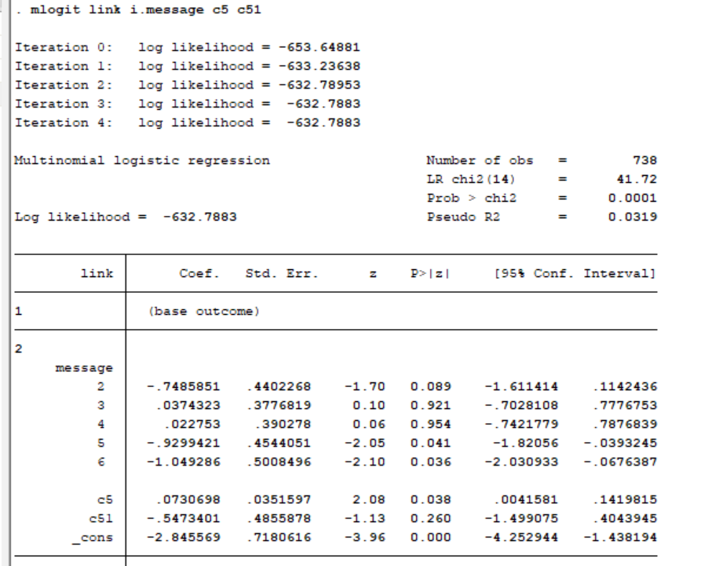

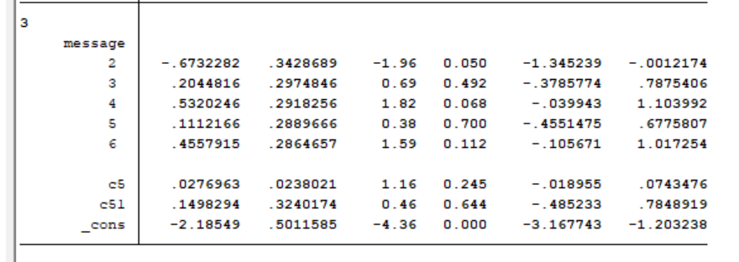

Model p-value= 0.0001 and Likelihood ratio chi square test of 41.72 tells us that our model as a whole fits significantly better than an empty model (i.e., a model with no predictors).

A one-unit increase in the variable c5 (Mother’s age) is associated with a .073 increase in the relative log odds of selecting in link 2 vs. link1. TO BE CONTINUED

Figure 14 Multinomial logistic regression investigating the effect of message and education level on reaction to letters

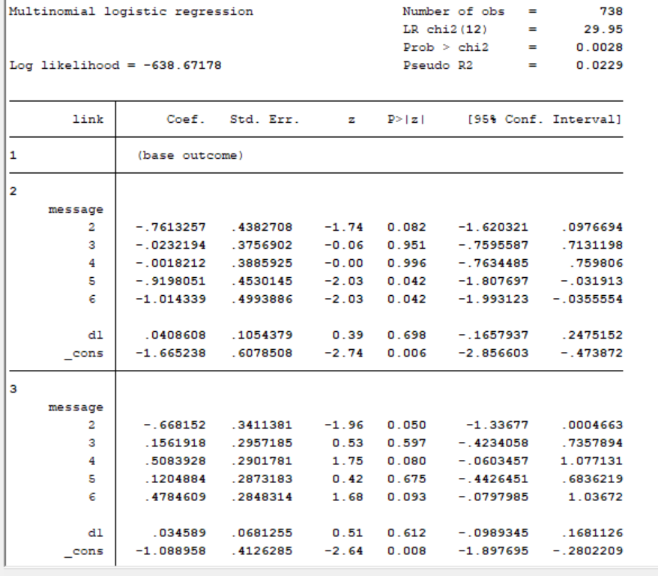

INTERPRETATION

Figure 15 Multinomial logistic regression investigating the effect of message and financial status on reaction to letters

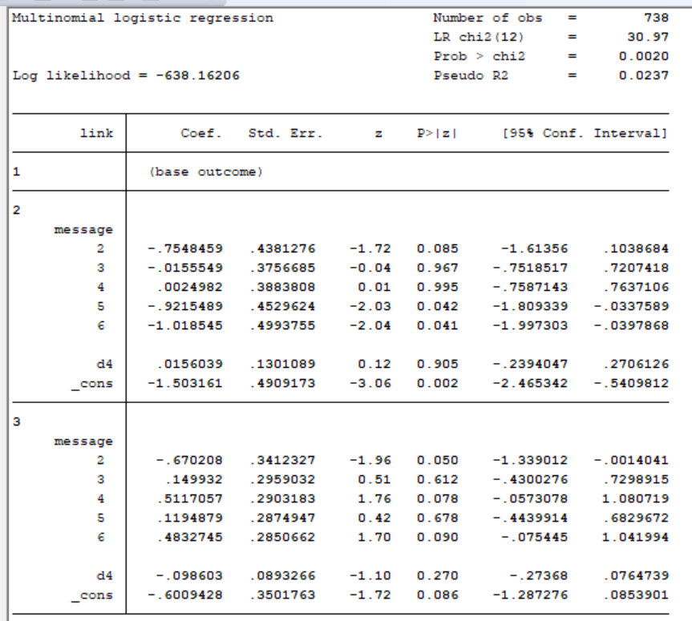

INTERPRETATION

**Conclusion and Recommendations**

According to the data analysis the first wave of the survey had the following insights:

* Interventions on MMR behavior had an impact on the attitude of parents towards vaccination against MMR.
* There was a relationship between attitude and likelihood to vaccinate in pre-test survey.
* There exist a relationship between attitude of a parent towards vaccination and the vaccination status of the child.
* After analyzing the first and second wave of the survey, intention to vaccinate a child changes, there are different intentions in each wave.
* There was a significant relationship between parent’s reaction and messages exposed to them with impact of letter 6 on the reaction being quite significant.
* Change in attitude is related to the message in a significant way, parents being exposed to letters from various authorities had an impact on their attitude towards vaccination.
* The impact of letters on the behaviors of parents, in terms of attitude (c13, q13) is unique for each letter. Only Letter 2 was significantly impactful on the change of attitude in parents. In terms of reaction letter 2 was significant in explaining the
* Letter 2 is significantly correlated with the behavior of mothers. It has a strong effect on mothers with positive attitudes (somewhat positive, neutral) and intentions (mothers without all vaccination that very likely will vaccinate).

From the findings of this study it’s recommended that communication to parents on matters regarding the vaccination of their children by signed by family doctor or a medical professional and the content elaborates the benefits of vaccination and the urgency of vaccination.

Appendices

Appendix A. Stata Codes

ttest c13==q13 /*paired sample t-test between pretest attitude and posttest attitude*/

ologit c11 c13 /*Ordered logistic regression model between pretest likelihood of vaccination and attitude*/

ologit c10 c13 /*Ordered logistic regression model between pretest vaccination status and attitude*/

ttest c11==q11 /*Paired t-tests to test the difference in the likelihood of vaccinating the current child (pre-test and post-test)*/

ttest c12==q12 /*Paired t-tests to test the difference in the likelihood of vaccinating another child (pre-test and post-test)*/

ologit link i.message i.c13 /*Ordered logistic regression between parent reactions (link) depending on message and the attitude (c13)*/

ologit link i.message /*Ordered logistic regression between parent reactions (link) depending on message given*/

gen att_change=q13-c13 /*generate a new variable att_change from a difference of two variables*/

ologit att_change i.message /*Ordered logistic regression between attitude changes (att_change) depending on message*/

tabulate messsage c10,chi2 lrchi2 /*chi square test of independence between vaccine status and message*/

tabulate messsage c13,chi2 lrchi2 /*chi square test of independence between attitude and message*/

olgit link i.message c5 c51 /*Ordered logistic regression between parent reaction to message and the control variable age*/

olgit link i.message i.d1 /*Ordered logistic regression between parent reaction to message and the control variable education*/

olgit link i.message i.d4 /*Ordered logistic regression between parent reaction to message and the control variable financial status*/

Appendix B. Graph

Box plots showing the average age of parents in each category of ‘reaction to the survey’ link



Link 1: average age was 34, Link2 and link3: average age was 35, Link 1 had more outliers meaning older or younger parents opted for link 1.